

**“Corporación educacional Gloria Méndez Briones”**

**“Educando con amor para formar grandes personas”**

**ASIGNATURA: Inglés NIVEL: 6to**

**ACTIVIDAD N°: 12 PROFESOR/A: Eduardo Vargas**

**Objetivo de la actividad:** Practicar comprensión lectora en relación a; restaurantes, comidas y acciones propias de la unidad.

**Instruction 1:** Read the different types of restaurant and answerthe following questions in English.

(Lee los diferentes tiposd e restaurantes y responde las preguntas en inglés).

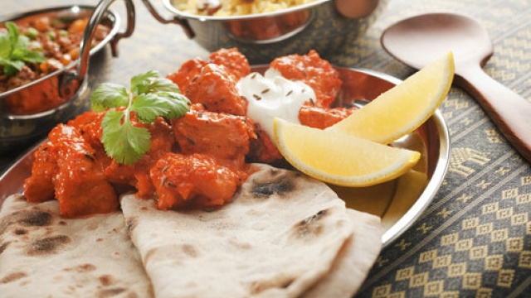

## **Food and restaurants**

Are you looking for somewhere special to go this weekend? Do you want to try something new? Check out one of these hot new restaurants.

#### **Last Days of the Raj**

A centrally located Indian restaurant, perfect for eating before or after the cinema or a show. In summer enjoy your meal in the beautiful garden. The most popular dishes are lamb and chicken cooked with mild, medium or hot spices. For brave customers there is extra hot!

#### **A Taste of Tuscany**

Whether you’d like a great value-for-money lunch or a relaxed evening meal in stylish surroundings, this is the place for you. The chefs have all been trained in Italy and they make both traditional and contemporary dishes. We recommend the pasta and seafood.

#### **Your Local Caff**

Remember when cafés served full English breakfasts – sausages, beans, fried bread, bacon and eggs – with a strong cup of tea? Well, this place still does and you can have your breakfast at any time you like during the day while you listen to your favourite tunes from the 1980s.

#### **The Lemon Tree**

This pretty restaurant serves healthy food that’s tasty too. Come in for a vegetarian snack at lunchtime or a great fruit smoothie or a cappuccino and a delicious piece of cake in the afternoon. Food is bought from local producers whenever possible.

#### **Cheesy Bites**

A restaurant that only serves cheese, but hundreds of cheeses from many countries and in lots of different forms. They serve reasonably priced lunches but dinner can be expensive. Lovely food and a very elegant dining room, looking onto an amazing flower garden.

#### **Fast Best**

Fast food doesn’t have to be junk food, as this café proves. Do you fancy a really good hamburger made with the best ingredients, or old-fashioned fish and chips fried to perfection, all on the table in super-quick time? Speed and quality are important here, and the prices aren’t bad either.

#### **The Chocolate Box**

The owner of this small café used to cook all kinds of food, but then she realised she preferred desserts to anything else. If you want meat or fish, don’t come here. They only do desserts! Lots of different kinds of sweets. Chocolate lovers will be excited by the range of chocolate cakes.

#### **Musical Chairs**

Have you noticed how music improves the taste of your food? This new restaurant has different types of live music every night except Sundays, and excellent food to go with it. Great fish dishes, steak and pizza. Monday is classic rock night, so see you there!

Questions

1. 'My girlfriend and I are vegetarian. Could you recommend a suitable restaurant for us?' Tom, aged 18

____________________________________________________

1. 'My mates and I all love spicy food. Can you recommend somewhere good for us to go tonight?' Dino, aged 21

____________________________________________________

1. 'I only get 30 minutes off for lunch and I'm in a hurry. Where can I get something quick to eat?' Melissa, aged 27

_____________________________________________________

1. 'Breakfast is the most important meal of the day in my opinion. Do you know anywhere that serves a good brekkie?' Micky, aged 38

_____________________________________________________

1. 'We love Italian food, especially pasta. Everyone loves Italian, don't they? Any good Italians near here?' Momo, aged 22

_____________________________________________________

|  |
| --- |
| **IMPORTANTE:**   1. **Puedes dibujar y desarrollar esta guía en tu cuaderno de Inglés.** 2. **Ante cualquier duda o consulta puede escribirme a mi correo** [**Eduardo.vargas@cegmb.cl**](mailto:Eduardo.vargas@cegmb.cl) 3. **Enviar al correo señalado solo 1 actividad desarrollada en esta guía, de esta forma poder realizar una retroalimentación y seguimiento del proceso de aprendizaje del estudiante.** |

