

**“Corporación Educacional Gloria Méndez Briones”**

**“Educando con amor para formar grandes personas”**

**ASIGNATURA:** Inglés **NIVEL:** Octavo

**ACTIVIDAD N°:** 14 **PROFESOR/A:** Beatriz Zapata Jaque

**Objetivo de la actividad:** To identify rules for changing adjectives into comparatives. Write comparatives sentences.

**Instrucciones:**

1. Copy and paste this direction in the Google directions bar: <https://youtu.be/5qr283nIC-I> (En esta oportunidad pega esta dirección en la barra de direcciones de Google)

2. Open your Student´s Book, page 37. With the information about these countries, complete the comparative sentences.

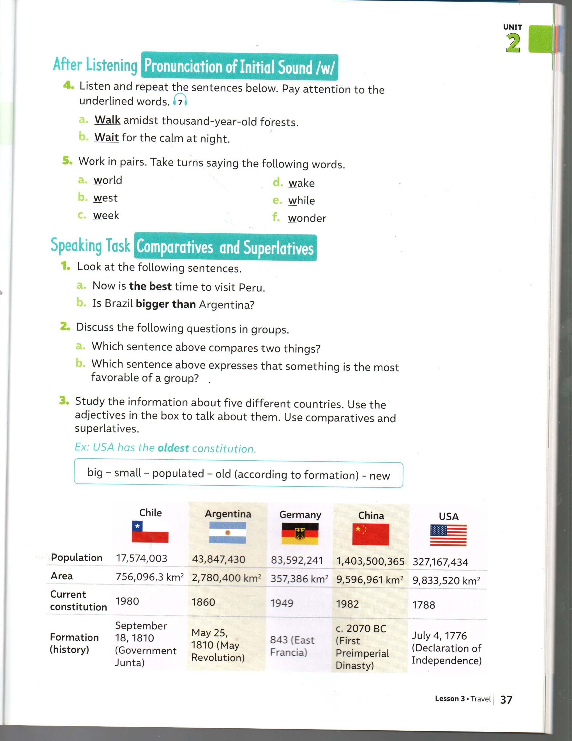

a. China is than USA. (populated)

b. Chile is than USA. (new)

c. Argentina is than Chile ( big)

d. Germany is than Argentina. ( small)

3. Open your Activity Book, page 21. Use the adjectives in the box. (Recuerda que cuando escribas tus oraciones comparativas debes transformar el adjetivo a su forma comparativa).

|  |
| --- |
| **beautiful small friendly ugly attractive** |

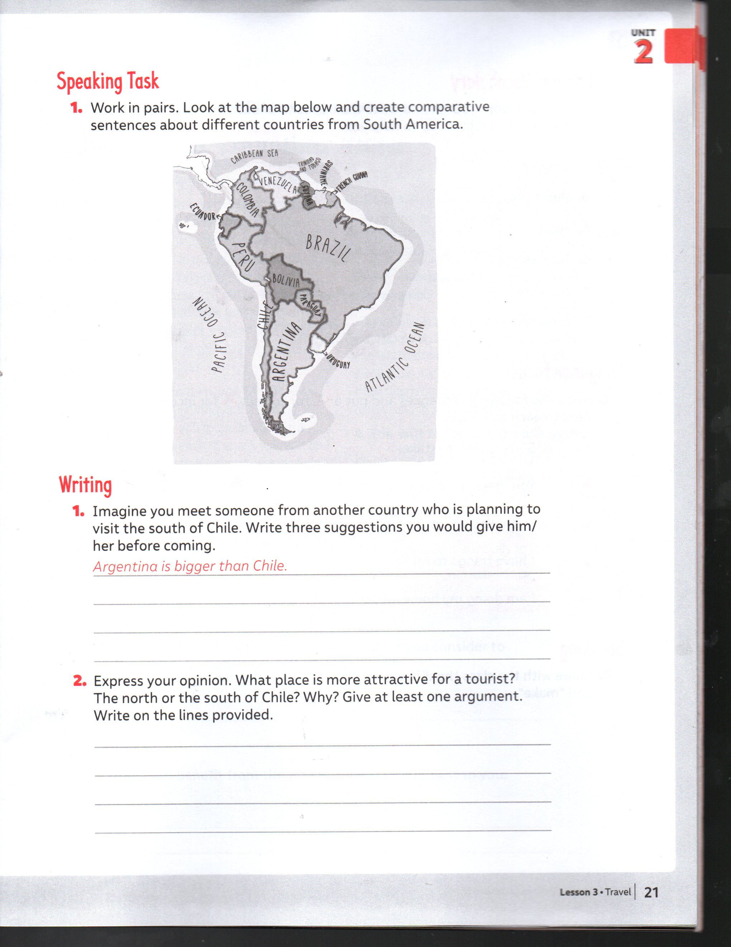

4. Open your Activity Book, page 21. Express your opinion. The north or the south of Chile? Why?

|  |
| --- |
| ***What place is more attractive for a tourist?*** _____________________________  ***Why?*** Because__________________________________________________ |

5. Open your Activity Book, page 22. Write the opposite for each word. Use a dictionary.

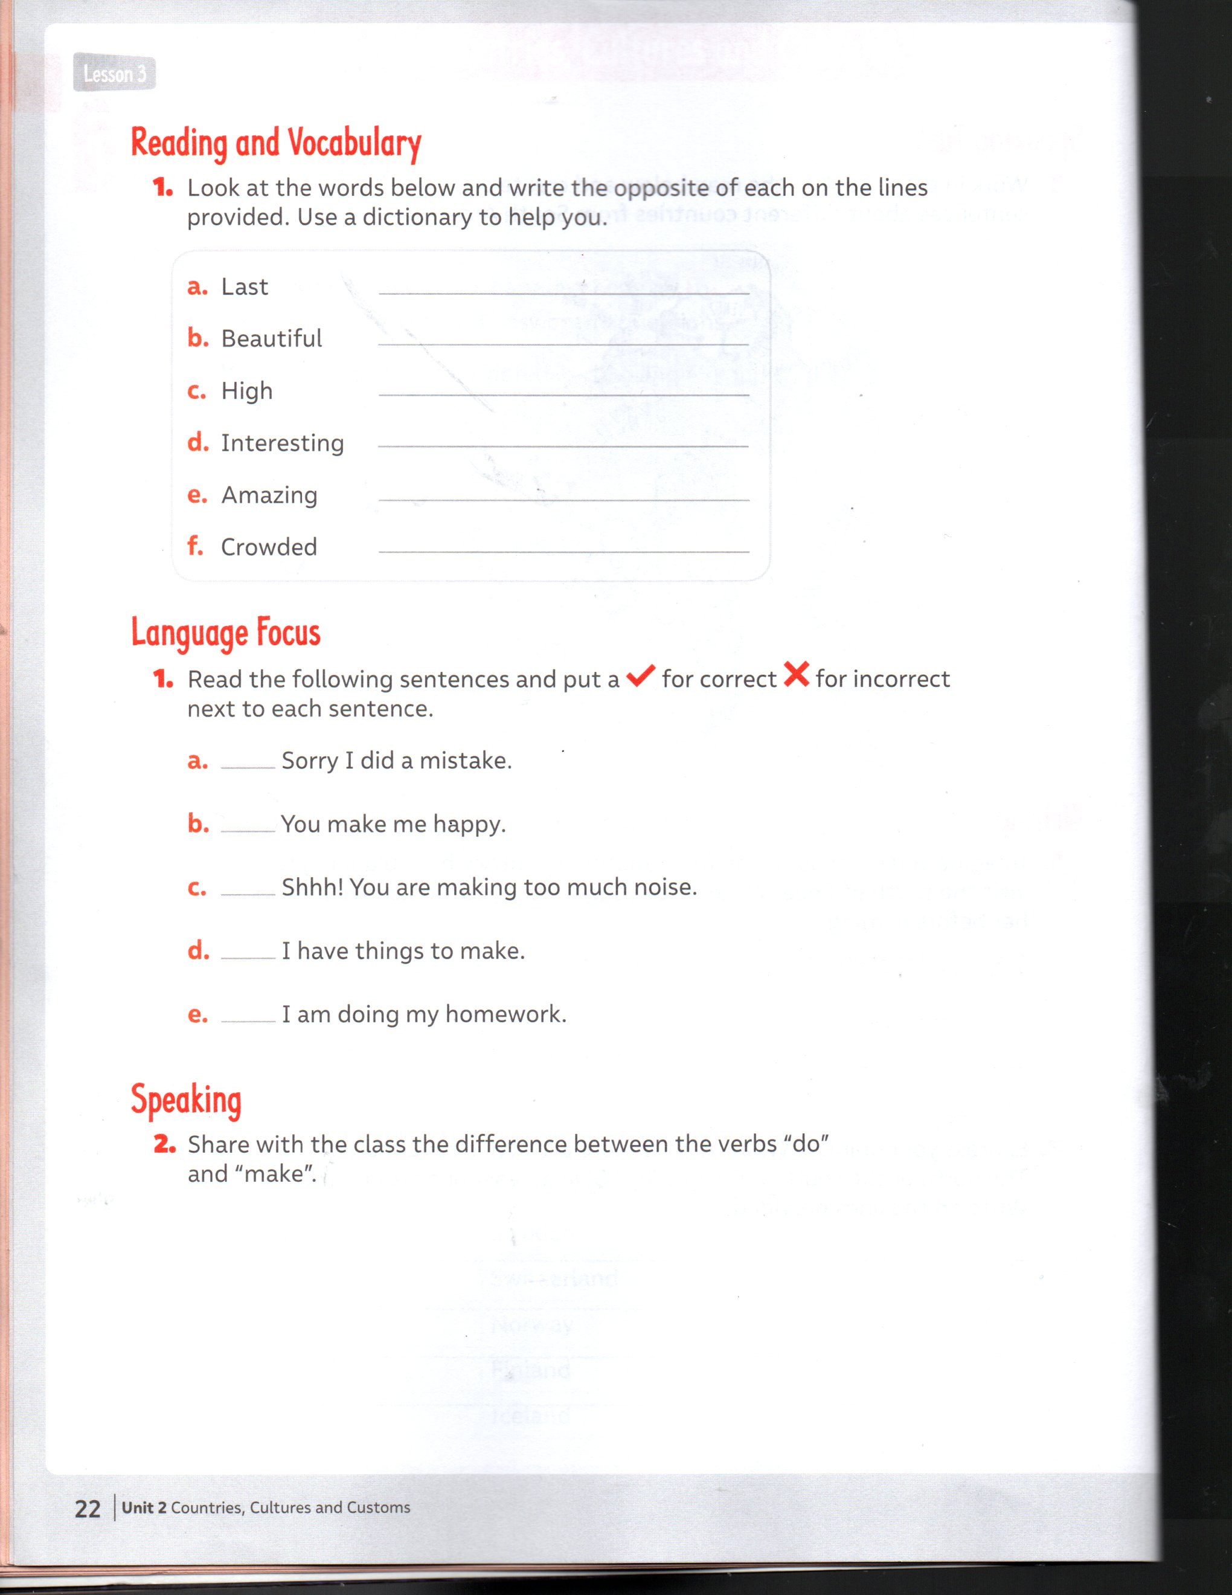

|  |
| --- |
| **IMPORTANTE:**  Enviar desarrollo de los ítems 2,3 y 5 al correo: beatriz.zapata@cegmb.cl |