

**“Corporación Educacional Gloria Méndez Briones”**

**“Educando con amor para formar grandes personas”**

**ASIGNATURA:** Inglés **NIVEL:** Octavo

**ACTIVIDAD N°:** 12 **PROFESOR/A:** Beatriz Zapata Jaque

**Objetivo de la actividad:** To identify the use of “so” for connecting ideas. To express preferences.

**Instrucciones:**

1. Copy and paste this direction in the Youtube directions bar: <https://youtu.be/vHjAjGh4n5s>. Pay attention to the explanation and the examples.

2. Match the sentences. (Para unir vas a INSERTAR – FORMAS – FLECHA – Te posicionas desde donde y hasta donde quieres unir).

|  |
| --- |
| 1. I was thirsty, so I failed the exam.  2. Lisa has got a new bike, so I need to take an aspirin.  3. The room was dark, so I turned on the light.  4. I didn ’ t study, so She didn´t buy any.  5.  It began to rain, so She rides her bike every day.  6. She doesn’t like rice, so There are no flights today.  7. They both have good jobs, so  We stayed at home.  8. The pilots are all on strike, so  They have plenty of money.  9. It was raining, so  I drank some water  10. I have a headache, so I opened my umbrella. |

3. Copy and paste this direction in the Youtube directions bar: https://youtu.be/zQv7oxTwIi8.

Pay attention to the explanation and the examples.

4. Open your Student’s Book, page 24. Write your own preferences. Use:

I like - I enjoy - I love - I don´t like - I hate - I don´t mind. Use the words in the box below. Do it as in the example.

Example:

I like mass media.

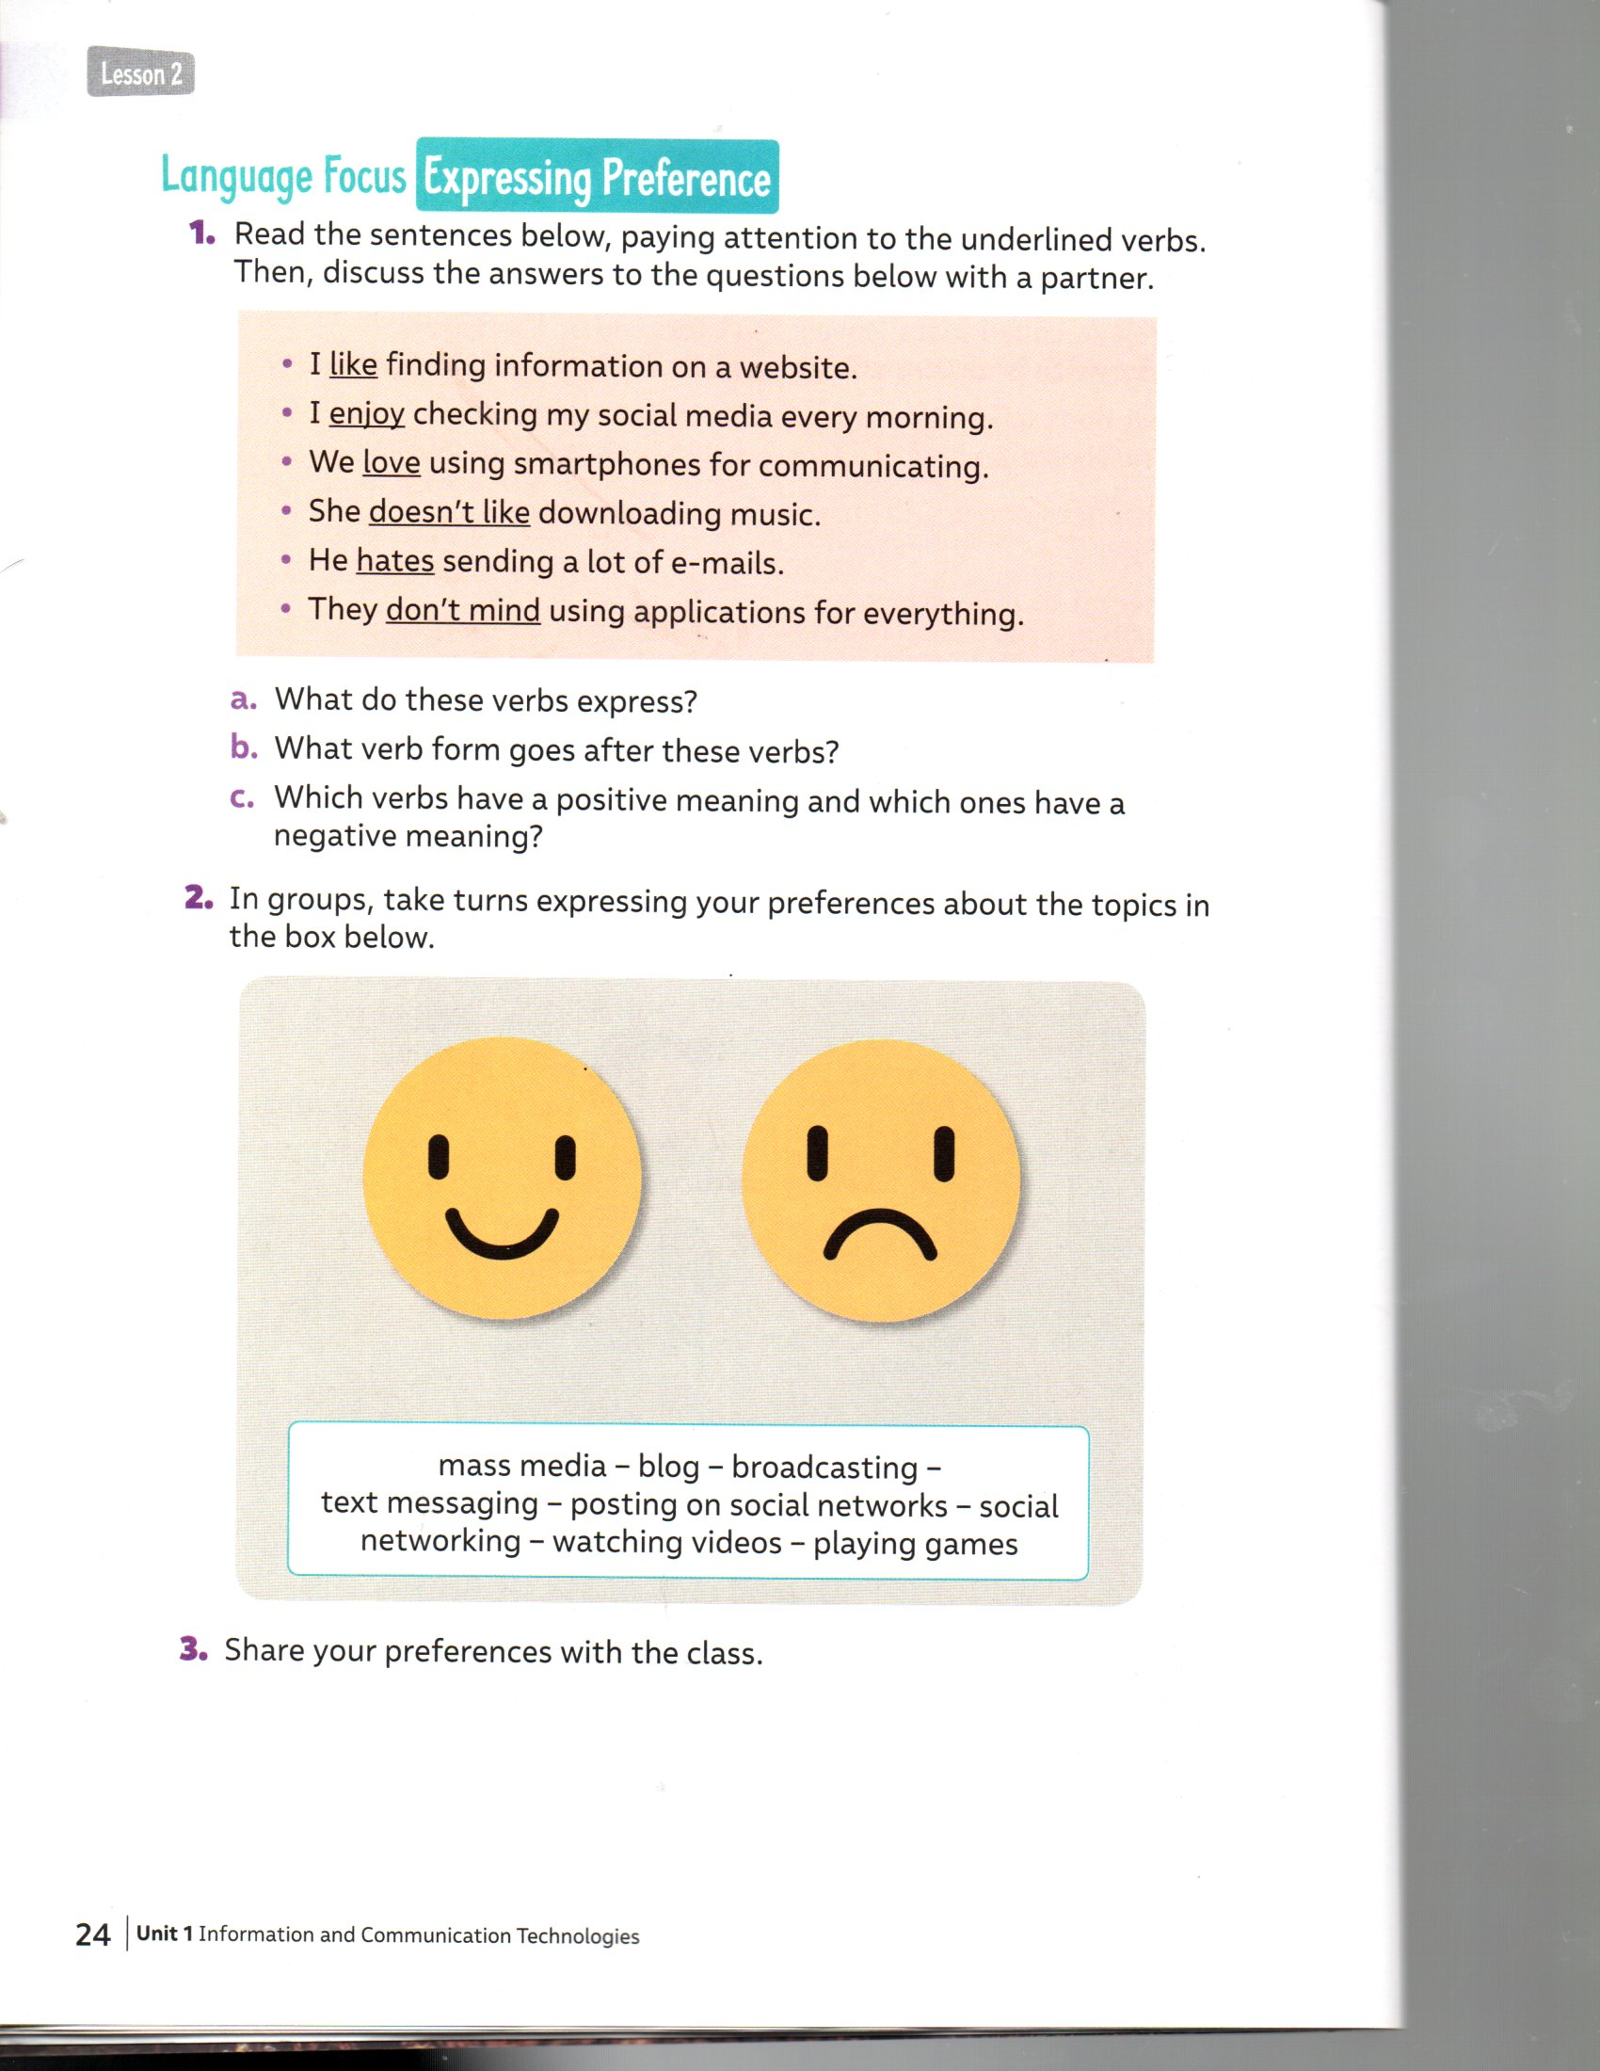

a) blog.

b) broadcasting.

c) text messaging.

d) posting on social networks.

e) social networking.

f) watching videos.

g) playing games.

|  |
| --- |
| **IMPORTANTE:** Enviar desarrollo de los items 2 y 4 al correo: beatriz.zapata@cegmb.cl |