****

**“Corporación Educacional Gloria Méndez Briones”**

**“Educando con amor para formar grandes personas”**

**ASIGNATURA:** Inglés **NIVEL:** Octavo

**ACTIVIDAD N°:** 9 **PROFESOR/A:** Beatriz Zapata Jaque

**Objetivo de la actividad:** To listen and understand about “Social Media”. To develop listening, Reading and writing skills.

**Instrucciones:**

**Before Listening**

1. Look and pay attention to this image:



2. Open your Student´s Book, page 18. Read and answer.

|  |  |
| --- | --- |
| Do you use social network? |  |
| Which one do you use the most? |  |
| What is your favorite social media platform |  |
| Why? | Because |

**While Listening**

3. Open your Student´s Book, page18. Copy and paste this direction in the Youtube directions bar: <https://youtu.be/SUBlPd2x42o> Listen to the report and match the two parts of the sentences.

|  |
| --- |
| C:\Users\beatriz\AppData\Local\Microsoft\Windows\INetCache\Content.Word\img20200606_15083163.jpg |

4. Open your Student´s Book, page18. Listen again and match. Use the letters **a** and **b** What does it mean? (Escucha nuevamente el audio).

|  |  |  |
| --- | --- | --- |
| a) The boss of the largest social network in the world said it was a big achievement. |  | Many people around the world use the platform created by Mark Zuckerberg to connect with their family and friends |
| b) It´s just the beginning of connecting the whole world to bring stronger relationships with those you love. |  | Because a billion people used the largest social network in the world in one day for the first time |

**After Listening**

5. Answer these two questions.

a) Do you think the social network created by Mark Zuckerberg is the most popular nowadays?

|  |
| --- |
|  |

b) Do you think using social network is dangerous? Why or why not?

|  |
| --- |
|  |

6. Open your Activity Book, page 13. Define the following concepts with your own words or find a definition in Internet.

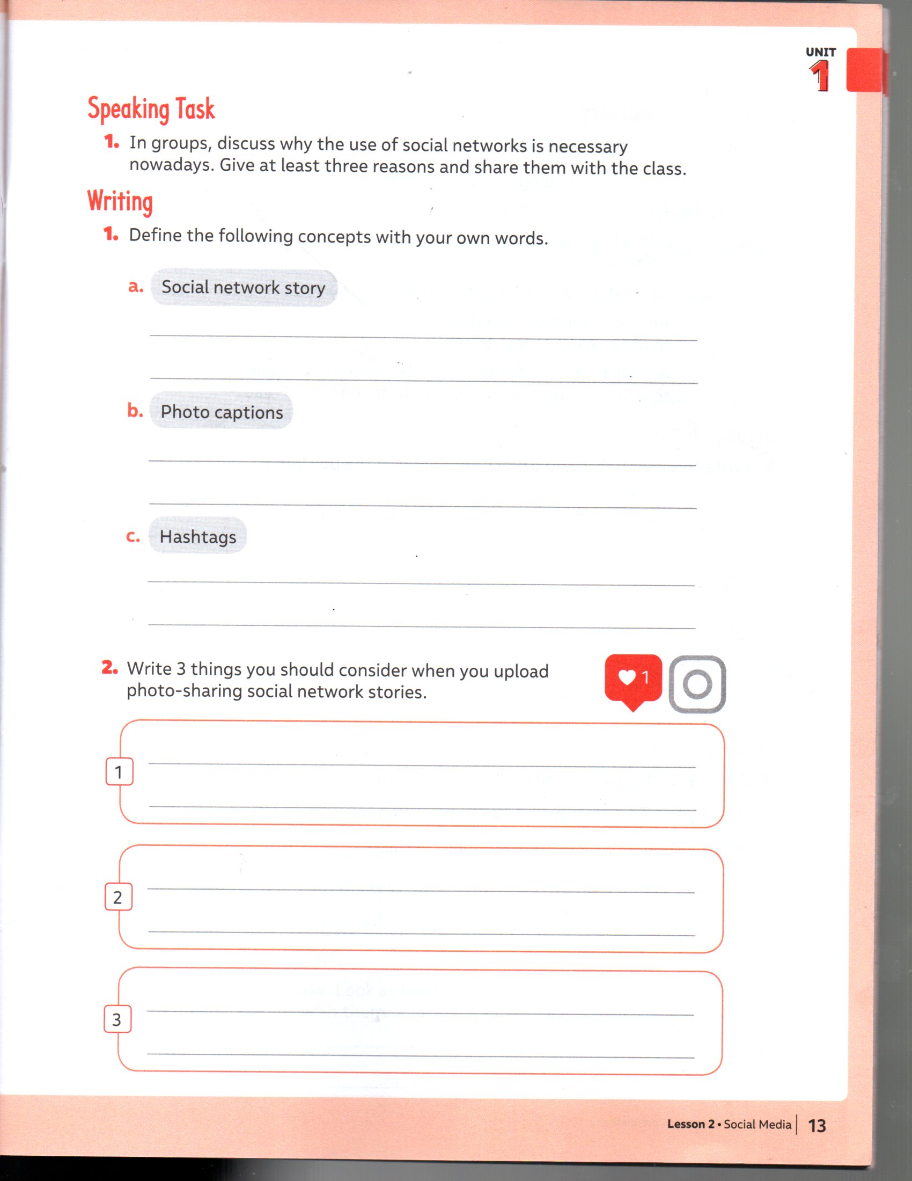

7. Write 3 things you should consider when you upload photos to the social networks. (Hazlo de acuerdo al grado de importancia según tu opinión).

|  |  |
| --- | --- |
| C:\Users\beatriz\AppData\Local\Microsoft\Windows\INetCache\Content.Word\img20200606_15210870.jpg | * Select interesting photos you want to show to your friends. * Make sure the publication is for all the people or just for my friends. * Upload photos in which I look good. |

|  |
| --- |
| **IMPORTANTE:**  Envía el desarrollo de los ítems 2, 3 y 7 al correo: beatriz. zapata@cegmb.cl. |