

**“Corporación Educacional Gloria Méndez Briones”**

**“Educando con amor para formar grandes personas”**

**ASIGNATURA:** Inglés **NIVEL:** Octavo

**ACTIVIDAD N°:** 7 **PROFESOR/A:** Beatriz Zapata Jaque

**Objetivo de la actividad:**

**Instrucciones:** Identify the diference betwen Possessive Adjectives and Possessive Pronouns.

1. Copy and paste these directions in the Youtube directions bar.

<https://www.youtube.com/watch?v=obgsPU76rLE> (El video de la pizarra verde)

<https://youtube.com/watch?v=Fvj7Ks-FqNE> (possessives audio octavo)

Here´s is the explanation of Possessive Pronouns and Possessive Adjectives.

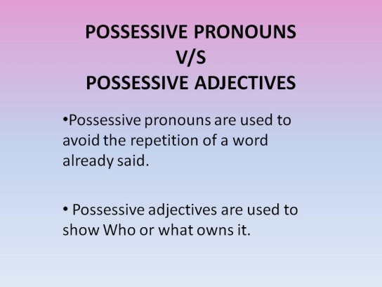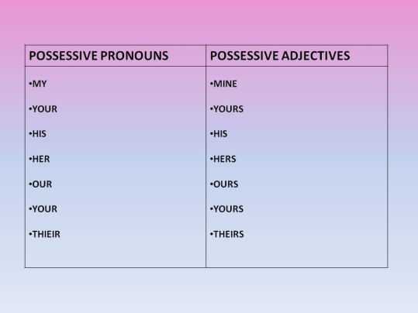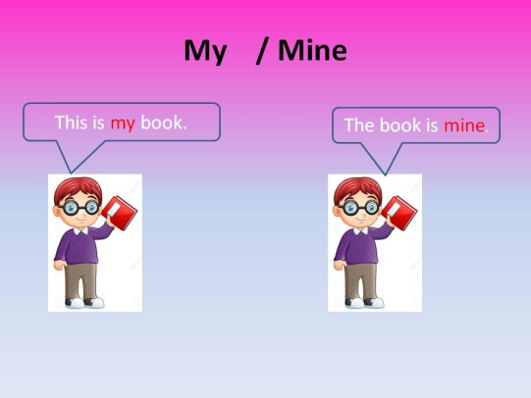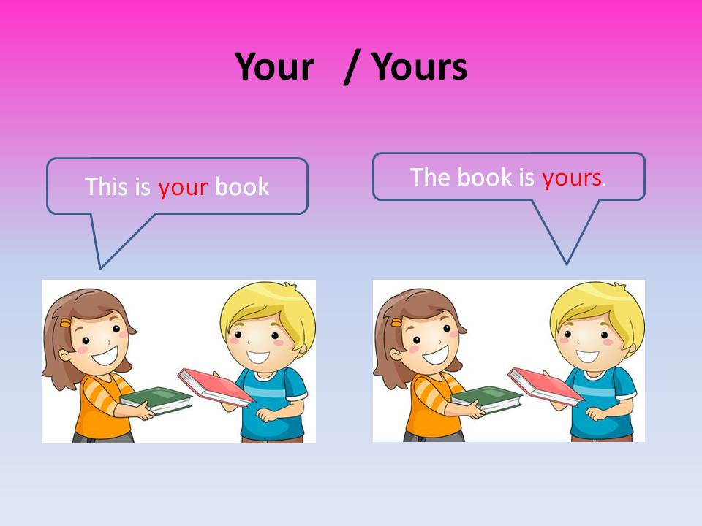 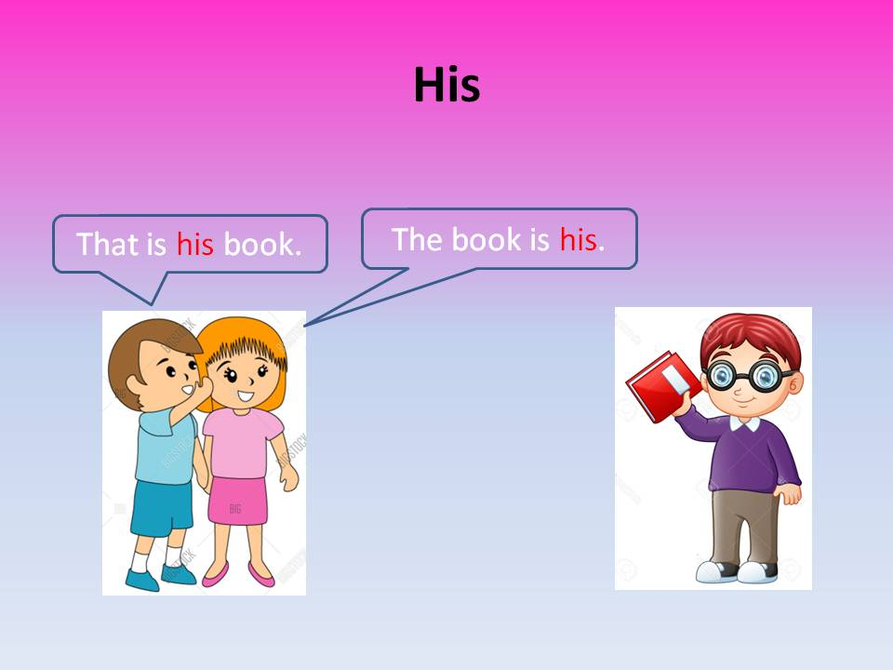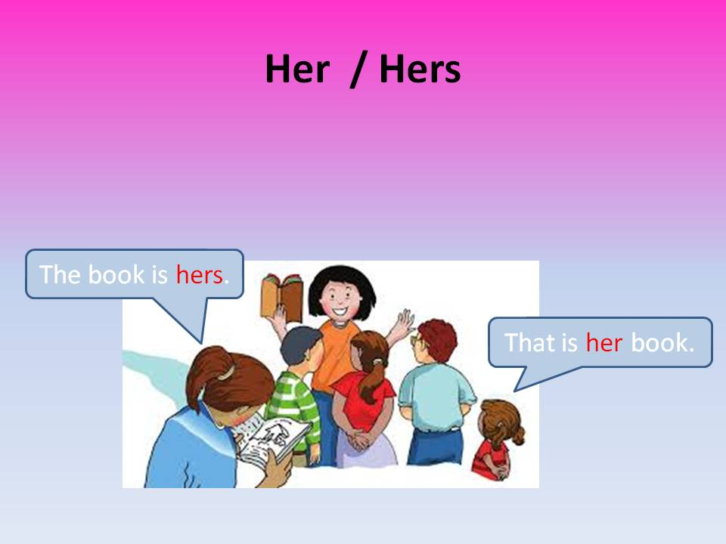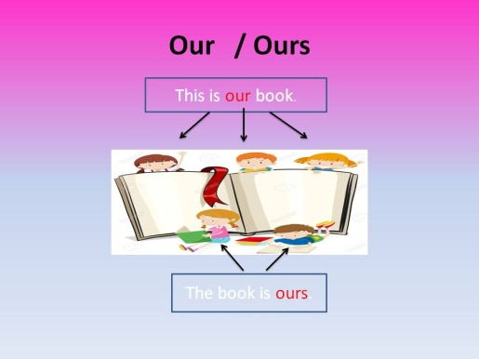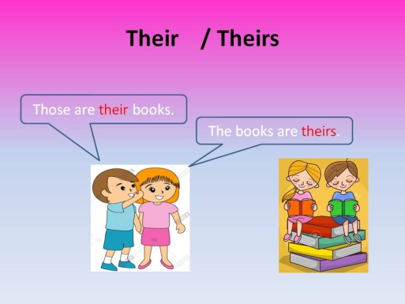

2. Copy and paste this direction in the Google directions bar: <https://agendaweb.org/exercises/grammar/possessive/adjectives-3> Check your score.

3. Read the sentences and underline the possessives prononoun.

Example: This is her umbrella.

a) Saturday is my favourite day.  
b) How many people live at your house?  
c) There was a fox in our garden.  
d) The dog is chasing its tail.  
e) Her car is very expensive.  
f) I have forgotten your present.  
g) He has a yellow hat on his head.

4. Complete with the Possessive Pronouns (yours- mine- theirs – his – hers – ours)

1. I'm riding my bike. The bike is_____
2. The ring belongs to Lucy. It is _____
3. We have a computer. The computer is _____
4. This garden belongs to John and Peter. It is _______
5. I have two cats. They are ______

5. Open your Student’s Book, page 12. Exercises 2. Complete with the correct possessive pronoun.

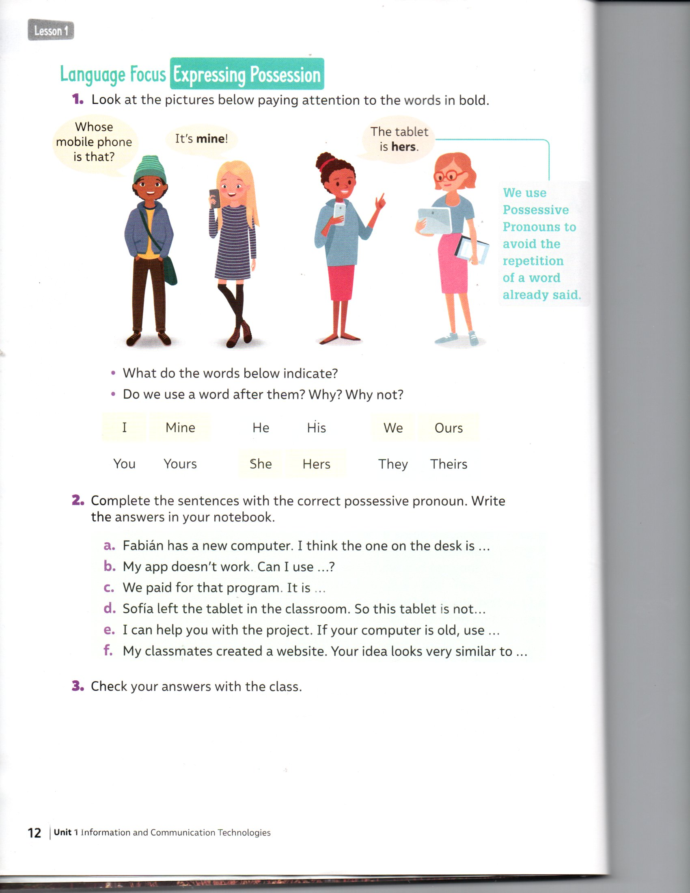

6. Open your Activity, page 6. Develop the exercises.

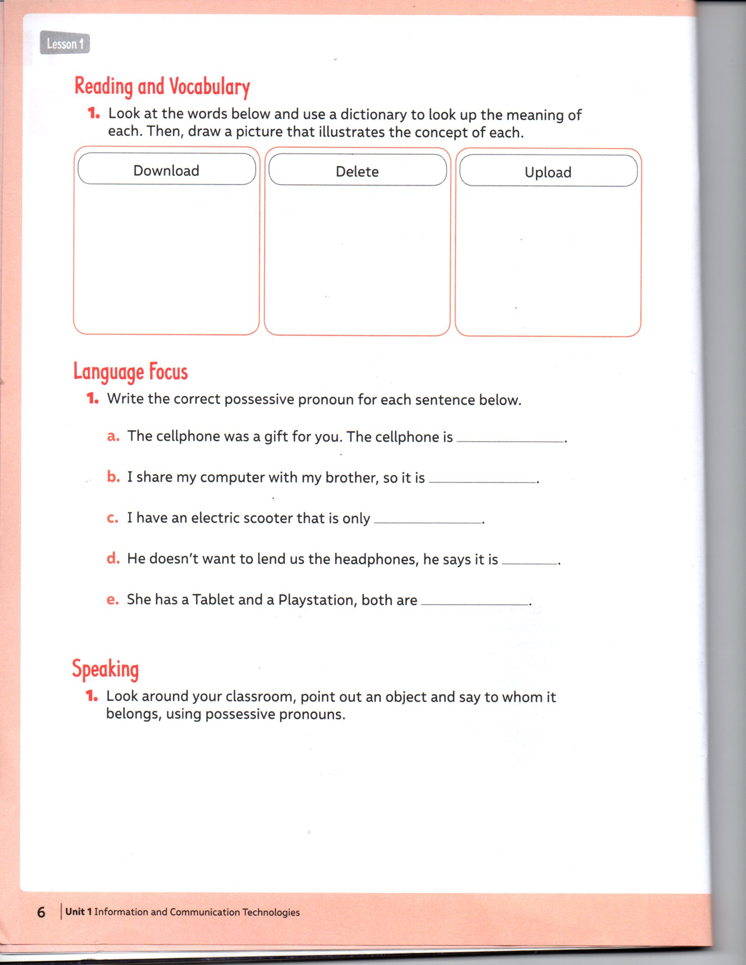

|  |
| --- |
| **IMPORTANTE:**  Envía el desarrollo de los ejercicios de los items 3, 5 y 6 al correo: beatriz.zapata@cegmb.cl |