

**“Corporación Educacional Gloria Méndez Briones”**

**“Educando con amor para formar grandes personas”**

**ASIGNATURA:** Inglés **NIVEL:** Octavo

**ACTIVIDAD N°:** 11 **PROFESOR/A:** Beatriz Zapata Jaque

**Objetivo de la actividad:** To read and understand a text about Social Media. To develop reading comprehension exercises. To reinforce the use of “Should” and “Shouldn´t”.

**Instrucciones:**

“In the previous activity (Activity 10). We introduced the reading for today”

**While Reading:**

1. Open your Student´s Book, page 21. Read the text and answer the questions below, If you prefer, you can answer in this document.

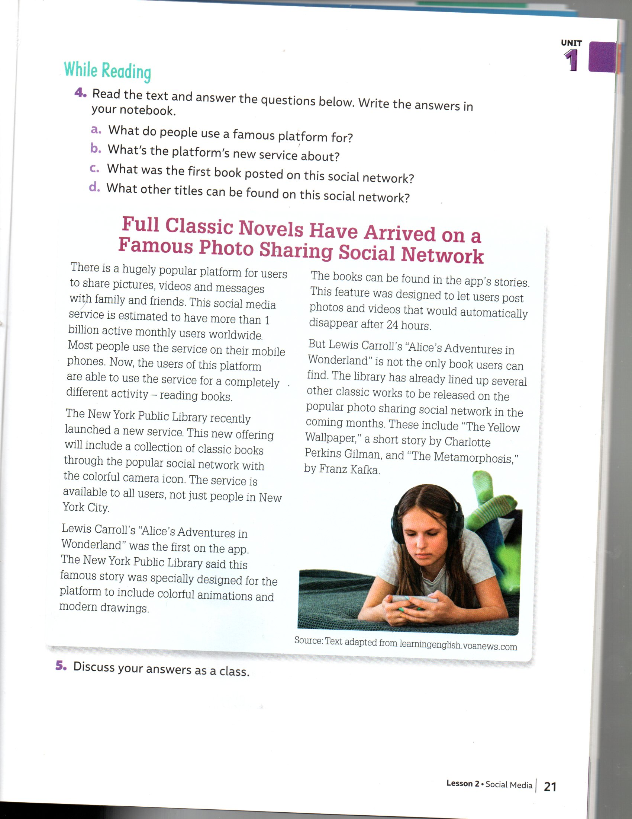

a) What do people use a famous platform for?

|  |
| --- |
|  |

b) What´s the platform´s new service about?

|  |
| --- |
|  |

c) What was the first book posted on this social network?

|  |
| --- |
|  |

d) What other titles can be found on this social network?

|  |
| --- |
|  |

**After Reading:**

2. Open your Student´s Book, page 22. Answer:

a) What other ideas can you think of to include educational material in social networks?

|  |
| --- |
|  |

b) What other books would you like to read on the social networks´ stories?

|  |
| --- |
|  |

3. Open your Activity Book, page 16. Read the statements and put a tick (√) or a cross (X) depending on what you **should** or **shouldn´t** do.

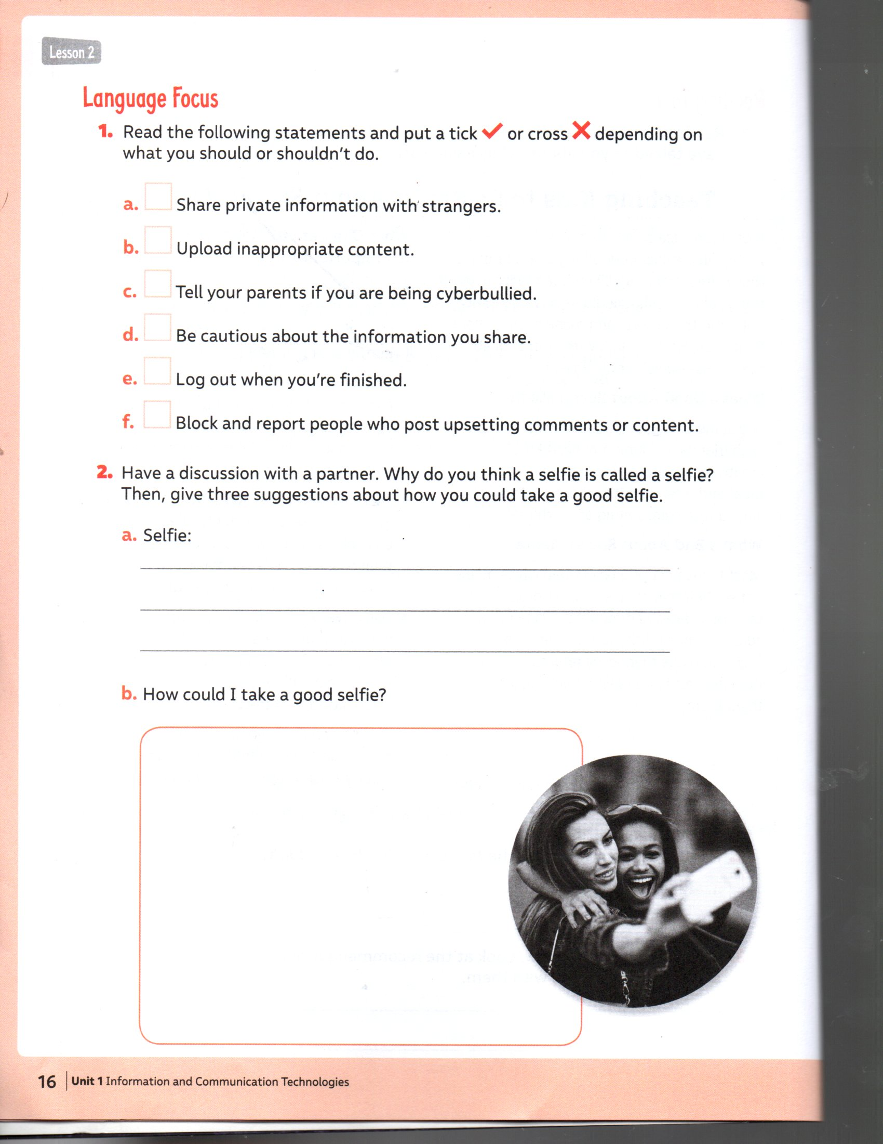

|  |
| --- |
| **IMPORTANTE:**  Enviar el desarrollo de los ítems 1, 2 y 3 al correo: [beatriz.zapata@cegmb.cl](mailto:beatriz.zapata@cegmb.cl) |