****

**“Corporación Educacional Gloria Méndez Briones”**

**“Educando con amor para formar grandes personas”**

**ASIGNATURA:** Inglés **NIVEL: O**ctavo

**ACTIVIDAD N°:** 6 **PROFESOR/A:** Beatriz Zapata Jaque

**Objetivo de la actividad:** To develop listening comprehension, reading and writing skills about the world of Apps.

**Instrucciones:**

**Pre listening:**

1. Look and read key vocabulary.

|  |  |
| --- | --- |
| Blind people | Persons with visual problems. |
| App | Cellphone Application |
| Lookout | The name of the application |
| Shopping setting | Help persons to capture products and identify money. |
| Quick Read (QR code) | For scanning . |

**Listening:**

2. Copy and paste this direction in the Youtube direction bar <https://youtu.be/mDCwumGx5PA> (Here is the audio).

**Post Listening:**

3. Open your Activity book, page 4. Listen to the recording and answer the questions. Choose one of the alternatives.

|  |
| --- |
| common people - blind people - deaf people |

a) What was this app designed for?

\_\_\_\_\_\_\_\_\_\_\_\_\_\_\_\_\_\_\_\_\_\_\_\_\_\_\_

|  |
| --- |
| Google Pixel device - Google Lens – Google Lookout |

b) What´s the name of the app?

\_\_\_\_\_\_\_\_\_\_\_\_\_\_\_\_\_\_\_\_\_\_\_\_\_\_\_

|  |
| --- |
| Free - 100 dollars - 500 dollars |

c) How much do users have to pay

for this app?

\_\_\_\_\_\_\_\_\_\_\_\_\_\_\_\_\_\_\_\_\_\_\_\_\_\_\_

|  |
| --- |
| Uses a dual system learning to recognize texts and objects |
| Uses a machine learning to recognize texts and objects |
| Uses an electronic system to recognize texts and objects. |

d) How does the app work?

\_\_\_\_\_\_\_\_\_\_\_\_\_\_\_\_\_\_\_\_\_\_\_\_\_\_\_

|  |
| --- |
| To provide fun to millions of blind people. |
| To provide money to millions of blind people. |
| To provide more independence to millions of blind people |

e) What is the main goal of the app?

\_\_\_\_\_\_\_\_\_\_\_\_\_\_\_\_\_\_\_\_\_\_\_\_\_\_\_

4. Open your Activity book, page 4. Look at exercise 2. Listen and match in your book.

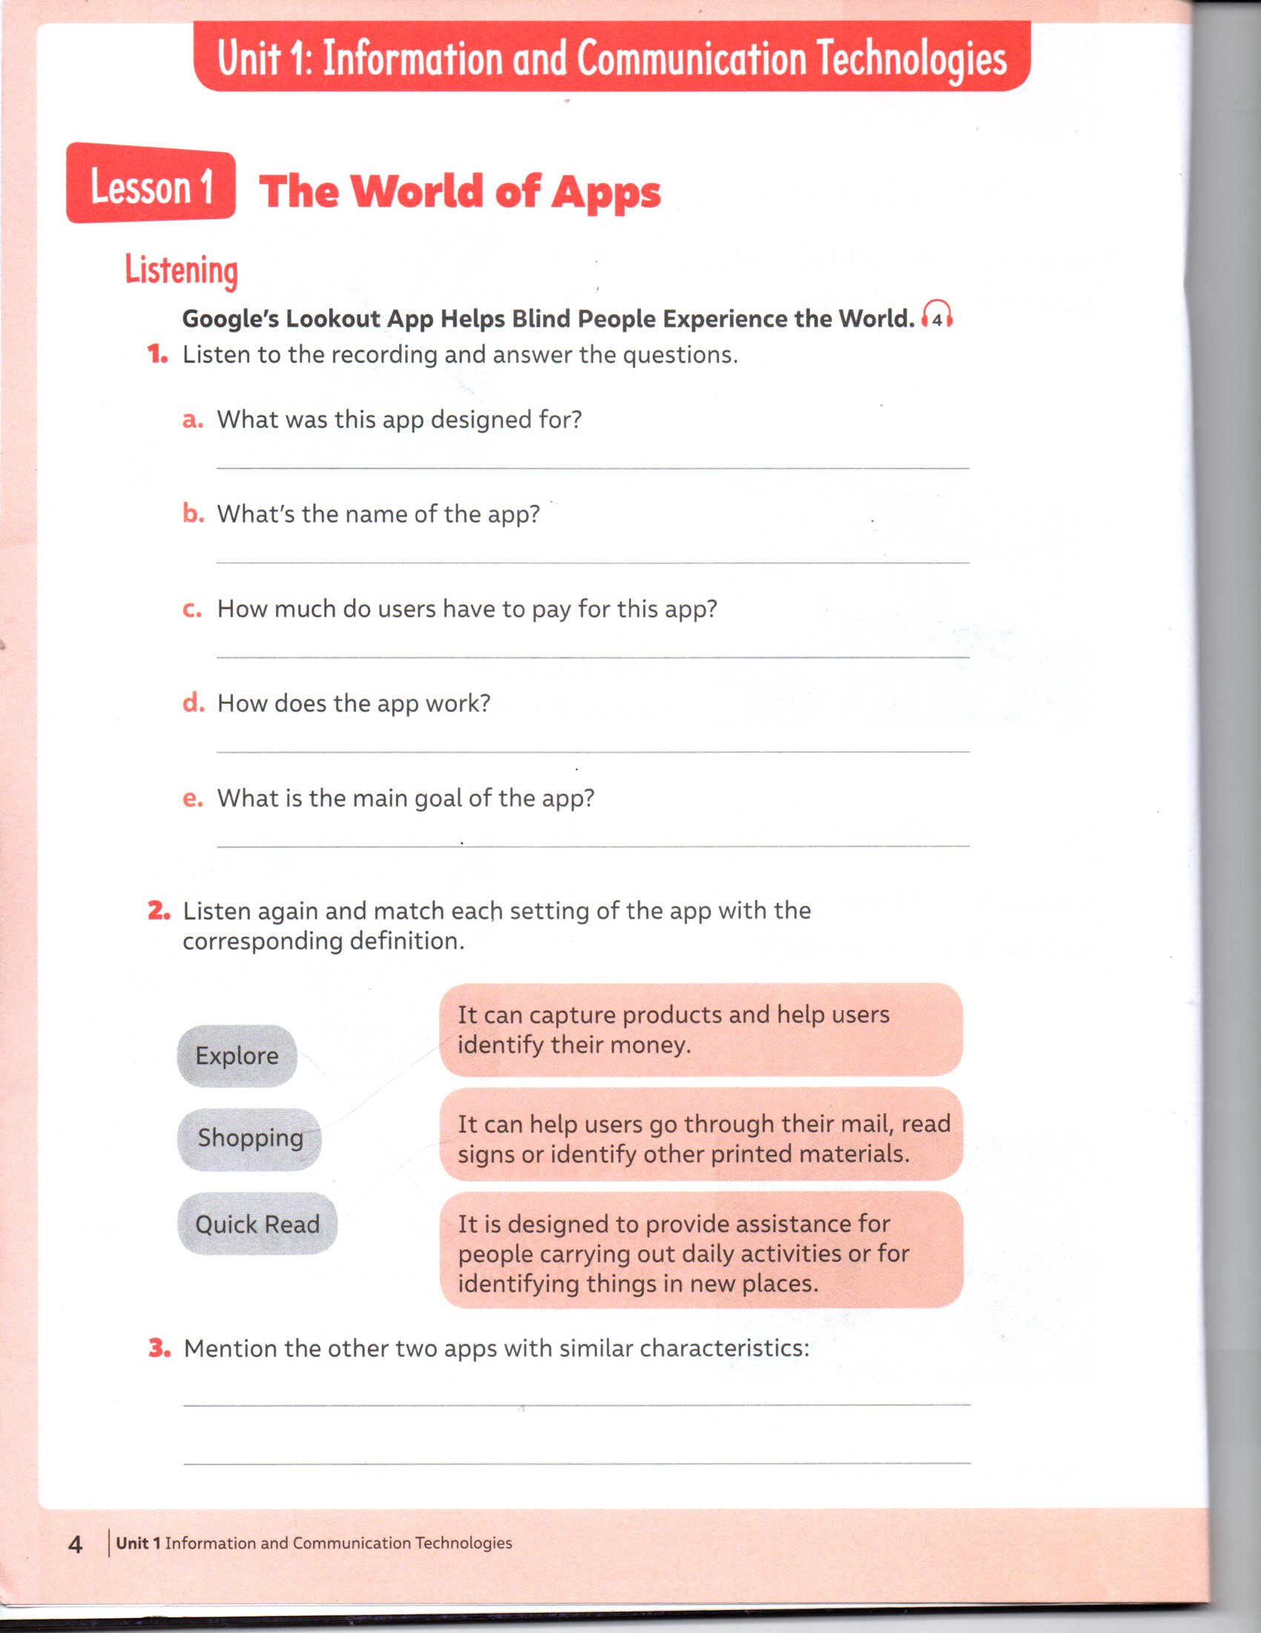

5. Open your Activity Book, page 5.

|  |
| --- |
| C:\Users\beatriz\AppData\Local\Microsoft\Windows\INetCache\Content.Word\img20200522_16415887.jpg |

a) How many times a week do you use the app?

\_\_\_\_\_\_\_\_\_\_\_\_\_\_\_\_\_\_\_\_\_\_\_\_\_\_\_\_\_\_\_\_\_\_\_\_ ( A few days - A lot - All the time )

b) How long have you used it?

\_\_\_\_\_\_\_\_\_\_\_\_\_\_\_\_\_\_\_\_\_\_\_\_\_\_\_\_\_\_\_\_\_\_\_\_ ( A little - A few months - A lot of time)

6. Open your Activity Book, page 5. Write about an electronic device that has changed your life. Work in your book.

|  |
| --- |
| My favourite electronic device is \_\_\_\_\_\_\_\_\_\_\_\_\_\_\_\_.  It has changed my life because:  a) I can \_\_\_\_\_\_\_\_\_\_\_\_\_\_\_\_\_\_\_\_\_\_\_\_\_\_\_ , \_\_\_\_\_\_\_\_\_\_\_\_\_\_\_\_\_\_\_\_\_\_\_\_\_\_\_\_\_ and  \_\_\_\_\_\_\_\_\_\_\_\_\_\_\_\_\_\_\_\_\_\_\_\_\_\_\_\_\_\_ . |

|  |
| --- |
| **IMPORTANTE:**  Enviar al correo los ejercicios del item 3, 5 y 6 al correo: [beatriz.zapata@cegmb.cl](mailto:beatriz.zapata@cegmb.cl)  Si quieres puedes enviarme fotografía de tus actividades. |