

**“Corporación educacional Gloria Méndez Briones”**

**“Educando con amor para formar grandes personas”**

**ASIGNATURA: Inglés NIVEL: 7mo**

**ACTIVIDAD N°: 2 PROFESOR: Eduardo Vargas**

**Objetivo de la actividad:** Practicar vocabulario acerca de comidas y acciones que estan pasando en el momento.

**Instruction 1:**  Look at the images and write four ingredients you identify in english.

(Observa las imágenes y escribe en ingles 4 ingredientes que identifiques.)

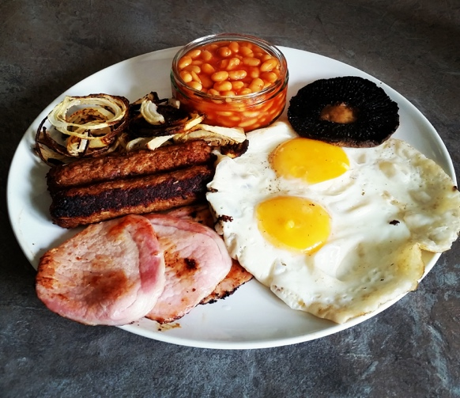 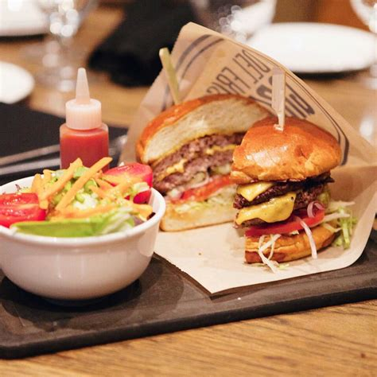

1. _____________________ 1. _____________________________
2. _____________________ 2. _____________________________
3. _____________________ 3. _____________________________
4. _____________________ 4. _____________________________

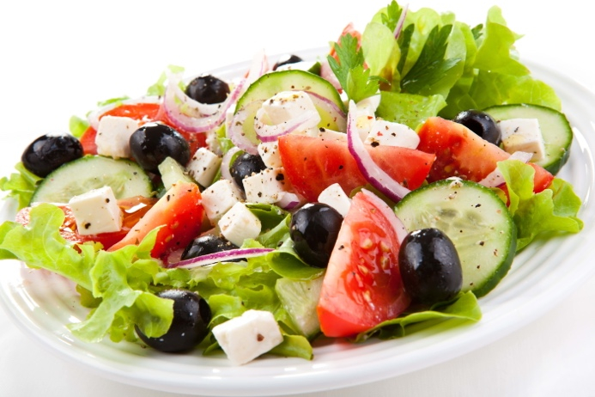

1. ____________________
2. ____________________
3. ____________________
4. ____________________

**Instruction 2:** Write in English what is happening in the restaurant. Use “Present Continuous”.

(Escribe en ingles que esta pasando en el restaurante. Usa Presente Continuo.)

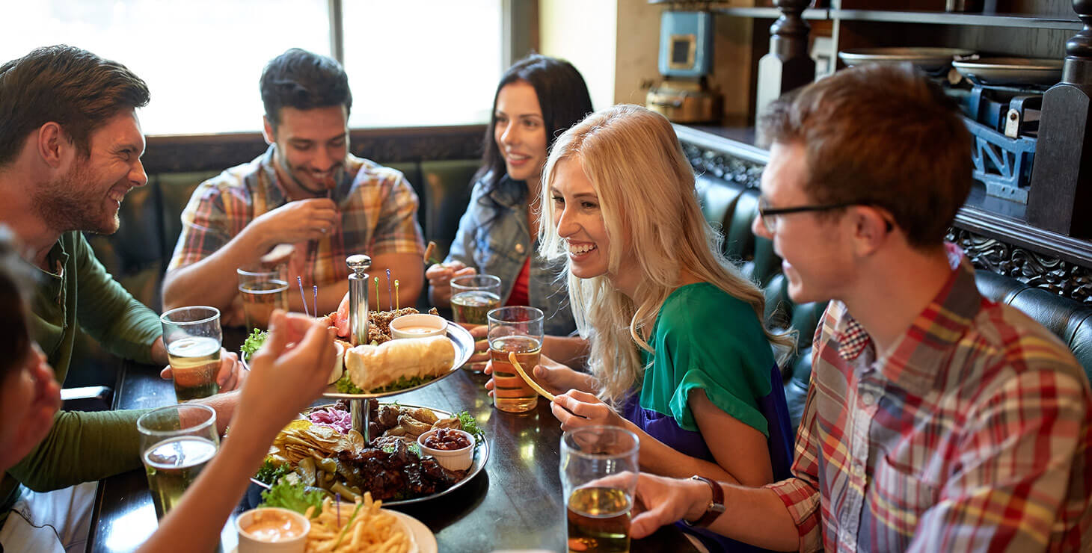

Example: The boy in green t-shirt is looking at the blond girl.

1. The girl in jean jacket is ______________________________________.
2. ________________________________________________________.
3. ________________________________________________________.

|  |
| --- |
| **IMPORTANTE: Puedes dibujar y desarrollar esta guía en tu cuaderno de inglés.** |

