

**“Corporación educacional Gloria Méndez Briones”**

**“Educando con amor para formar grandes personas”**

**ASIGNATURA: Inglés NIVEL: 6to**

**ACTIVIDAD N°: 2 PROFESOR/A: Eduardo Vargas**

**Objetivo de la actividad:** Practicar vocabulario de la familia y describirlos en inglés.

**Instruction 1:** Read the information about Laura´s family and answer the questions in english.

(Lee la información sobre la familia de Laura y responde las preguntas en inglés).

# Laura’s Family

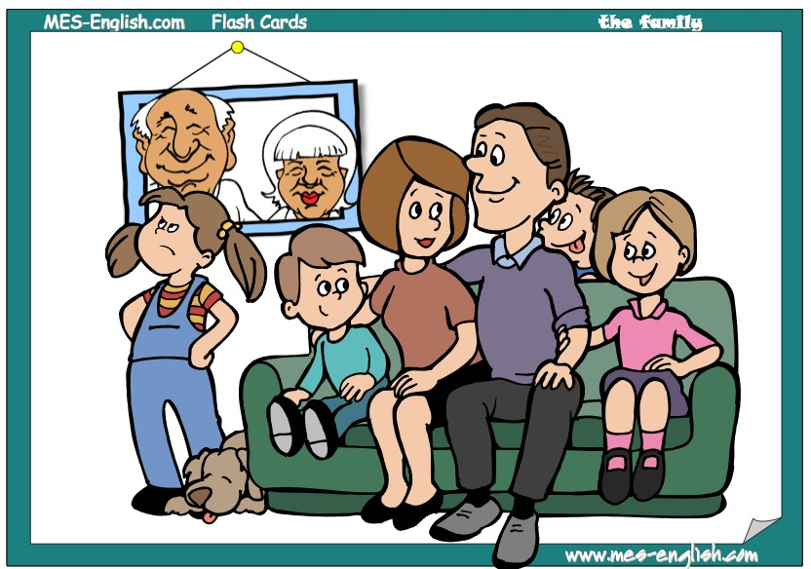

Michael

Annie

Sarah

John

Sam

Jess

Laura

Tom

Charlie

Hello, my name is Laura. I am eight years old. This is my family. I have two brothers and one sister. My older brother’s name is Sam. My younger brother’s name is Tom. My sister´s name is Jess. My mom’s name is Sarah and my dad’s name is John. My mom likes to read and my dad likes to watch TV. My grandparents are Michael and Annie. They are my dad’s parents. I also have a pet dog. His name is Charlie. He likes to sleep.

Who is Sam? ____________________________________________

What is the name of the sister of Laura? ____________________________

Who are John’s parents? __________________________________

How old is Laura? _________________________________________ Who is Laura’s younger brother? ______________________________

What does Sarah like to do? _________________________________.

**Instruction 2:** Describe 3 characters in the picture of the previous page using 2 adjectives.

( Describe 3 personajes de la foto anterior usando dos adjetivos).

**Example:** Tom is short and shy.

1. **______________ is _______________ and ____________________.**
2. **______________ is _______________ and ____________________.**
3. **______________ is _______________ and ____________________.**

|  |
| --- |
| **IMPORTANTE: Puedes dibujar y desarrollar esta guía en tu cuaderno de Inglés.** |

